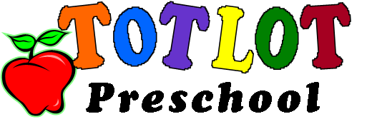
Dear Tot Lot Parents:

Who doesn’t LOVE taffy apples? Every year we hold a fundraiser for 3 and 4 year old preschool and this year it is a taffy apple fundraiser. The proceeds that are made go towards enhancing the preschool class room with educational materials and supplies. We ask that every participant purchase at least one case of taffy apples (24 taffy apples are in a case). There are three different types of taffy apples that you can choose from: plain, peanut, or sprinkles. Each taffy apple will be sold for $2.00 each. There are two different options you can choose from in regards to selling the taffy apples:
- Buy Out- Families that choose this option will not have to sell taffy apples, but instead pay a fee of $48.00 at registration.
- Families can purchase any 24 apples at the given price and turn in the money to the Preschool teacher. You then can keep them or sell them at the rate of $2.00 per apple.
The fundraiser will start at the beginning of September and order forms or buy outs are due no later than September 25th. Information and order forms will be sent home with the September newsletter. Any questions can be directed towards Mrs. Coni at (708)-448-7080 ext. 103.

Thank you,

Tot Lot Preschool Staff

